Chapter 13, Problem 56.

Find the power absorbed by the 10-Ω resistor in the ideal transformer circuit of Fig. 13.121.

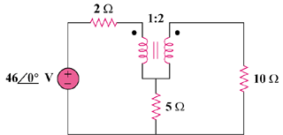

Figure 13.121
For Prob. 13.56.

